**VISVESVARAYA TECHNOLOGICAL UNIVERSITY BELGAUM**



A project report on

**“Smart Grid Compatible Control of Appliances using Internet Protocol”**

Submitted for the partial fulfillment of the requirement of the award of the degree of

**Bachelor of Engineering**

in

**Electrical and Electronics Engineering**

by

Prachet Verma 1BY09EE028

Prahlad Suresh 1BY09EE030

Sarath Vadakkepat 1BY09EE044

Under the guidance of

Mr. H. D. Kattimani

Associate Professor



Department of Electrical and Electronics Engineering

**BMS Institute of Technology**

PB No.6443, Avalahalli, Yelahanka, Doddaballapura Main Road, Bangalore-560064

|  |  |
| --- | --- |
| http://sevyam.com/SEVYAM/Education/Engineering/Images/bms-institute-of-technology-logo.png | **BMS Institute of Technology**  PB No.6443, Avalahalli, Yelahanka, Doddaballapura Main Road, Bangalore-560064 |

**Department of Electrical and Electronics Engineering**

**Certificate**

This is to certify that the project work titled **“Smart Grid Compatible Control of Appliances using Internet Protocol”** carried out by **Prachet Verma** (1BY09EE028), **Prahlad Suresh** (1BY09EE030) **and Sarath Vadakkepat** (1BY09EE044), bonaﬁde students of **BMS Institute of Technology**, in partial fulﬁllment of the requirements for the award of the degree of **Bachelor of Engineering** in **Electrical and Electronics Engineering** of **Visvesvaraya Technological University**, Belgaum during the year 2012-2013. It is certiﬁed that all corrections/suggestions indicated for internal assessment have been incorporated in the report deposited in the departmental library. The project report has been approved as it satisﬁes the academic requirements in respect of project work prescribed for the said degree.

**Mr. H. D. Kattimani Dr. T. C. Balachandra Dr. S. Venkateswaran**

Associate Professor Head of Department Principal

& Internal Guide EEE BMSIT

**External Viva**

**Name of Examiner Signature with date**

**1.**

**2.**

# Acknowledgement

We would like to express our gratitude and thanks to **BMS Institute of Technology**, for providing an opportunity for fulfilling our most cherished desire of reaching our goals and thus helping to pave a bright career for us.

We would like to extend our sincere gratitude and thanks to the Management, and to  **Dr. S. Venkateswaran**, Principal, BMSIT, for providing us with a congenial environment to work in.

We  would  like  to  sincerely thank  our  H.O.D, **Dr.  T. C. Balachandra**, Professor, Department of Electrical & Electronics Engineering, BMSIT, for his encouragement and support.

We would like to express our sincere gratitude to **Mr. H. D. Kattimani**, Associate  Professor,  Department of Electrical & Electronics Engineering, BMSIT, and our Internal guide, for  his valuable guidance, support and inputs, and for helping us with the project and prepare the report for the same.

We would like to express our sincere gratitude **Mr. Prashant A. Athavale**, Assistant Professor, Department of Electrical & Electronics Engineering, BMSIT, and our Project Coordinator, for his valuable guidance for completion of this project.

We also thank all the Faculty Members and Technical Staff of the **Department of Electrical & Electronics Engineering** for their continued support and guidance, and in helping us successfully complete our project.

We would also like to thank our parents and friends for extending their hands directly or indirectly at every juncture of need.

# Abstract

In this day and age of modern technology, it is only natural that the concept of home automation is fast gaining popularity around the world. Additionally, the problem of conserving energy takes importance in a world of rapidly depleting natural resources. Our project aims to enable control and monitoring of appliances through the internet and additionally help in energy conservation by means of occupancy detection coupled with automatic switch off of appliances. This is also in compliance with the smart grid initiatives being taken in the country.

Our project uses webcam-based occupancy detection and an Android App as the interface for control of appliances through the internet. A digital wall switch was also designed to replace the traditional arrangement. The main component of the project is the Raspberry Pi Model B, which is used as the control centre.

Using the Raspberry Pi and webcam decreases both the cost and size of implementing this project, and Android phones are almost ubiquitous. Hence it is possible to bring luxury and energy savings to many users, even in developing countries such as India.

# **Table of Contents**

Acknowledgement i

Abstract ii

Table of Contents iii

List of Figures vi

List of Tables viii

Chapter 1: Introduction 1

1.1 Home Automation 2

1.2 Motion Detection 2

1.3 Smart Grid 3

Chapter 2: Literature Survey 4

2.1 Introduction 5

2.2 Hardware Requirement 7

2.2.1 Raspberry Pi Model B 8

2.2.2 Webcam as an Occupancy Sensor 12

2.2.3 Solid State Relay 13

2.2.4 Seven-segment Display 13

2.2.5 BCD to 7-segment Decoder/Driver (74LS47) 15

2.3 Software Requirements 16

2.3.1 Android 16

2.3.2 Client-Server Model 16

2.3.3 Internet Protocols 17

Chapter 3: Scope of Present Work 18

3.1 Statement of the Project 19

3.2 Objectives 19

Chapter 4: Present Work 20

4.1 Software 21

4.1.1 Introduction 21

4.1.2 Web Camera program 22

4.1.3 Raspberry Pi programs 24

4.1.4 Switch Program 27

4.1.5 Driver Program for 7-segment Display 27

4.2 Hardware 30

4.2.1 Transformer 30

4.2.2 Power Supply Unit 31

4.2.3 Solid State Relay 33

4.2.4 Push-button Switches 35

4.2.5 Raspberry Pi Extension Board 35

Chapter 5: Results 38

5.1 Result 39

5.2 Applications 39

5.3 Advantages 39

5.4 Disadvantages 39

5.5 Screenshots of Android App 40

Chapter 6: Conclusion 48

6.1 Scope for future work 49

6.2 Task 49

6.3 Achievement 50

6.4 Final Opinion 50

Bibliography xi

Appendix: Datasheets A.1

A.1 Raspberry Pi A.2

A.2 MOC 3041 Zero-Cross Optoisolator Triac Driver A.7

A.3 BTB04-600SL Standard 4A Triac A.13

A.4 7447 BCD to 7-segment Decoder/Driver A.18

# List of Figures

Figure 1.1: Smart Grid 3

Figure 2.1: uControl Home Security, Monitoring and Automation 6

Figure 2.2: Raspberry Pi 8

Figure 2.3: Raspberry Pi Pin Diagram 10

Figure 2.4: Raspberry Pi Architecture Block Diagram 12

Figure 2.5: Solid State Relay 14

Figure 2.6: Seven-segment Display 14

Figure 2.7: Circuit for BCD to 7-segment display using 74LS47 15

Figure 2.8: Client-Server Model 16

Figure 4.1: Overview Block Diagram 21

Figure 4.2: Web Cam Program Flowchart 23

Figure 4.3: Raspberry Pi programs Block Diagram 24

Figure 4.4: Server Program flowchart 26

Figure 4.5: Switch Program flowchart 28

Figure 4.6: Flowchart for 7-segment display driver 29

Figure 4.7: Transformer 30

Figure 4.8: Power Supply Unit 31

Figure 4.9: Power Supply Circuit Diagram 32

Figure 4.10: Solid State Relay 33

Figure 4.11: SSR Circuit using MOC 3041 34

Figure 4.12: Push Button Switches 35

Figure 4.13: Switch circuit using transistor in cut-off and saturation regions 36

Figure 4.14: Raspberry Pi Extension Board Circuit Diagram 37

Figure 4.15: Raspberry Pi Extension Board Photograph 37

Figure 5.1: Login Screen 40

Figure 5.2: Login Successful 41

Figure 5.3: Panel Booting 41

Figure 5.4: Panel Booted and Healthy 42

Figure 5.5: Navigate Home screen 42

Figure 5.6: Configure IP 43

Figure 5.7: Bedroom Controls 43

Figure 5.8: Speed Control 44

Figure 5.9: Device Usage details 44

Figure 5.10: kWh Manager 45

Figure 5.11: Monthly Bill Details 45

Figure 5.12: Rate Slabs 46

Figure 5.13: Device-wise Unit Consumption 46

Figure 5.14: Room-wise Unit Consumption 47

Figure 5.15: Start and Stop Timer 47

# List of Tables

Table 2.1: Raspberry Pi Specifications 8

Table 2.2: Truth table for BCD to 7-segment display using 74LS47 15

# Chapter 1: Introduction

This chapter provides a basic introduction to the various concepts relating to Home Automation and Smart Grid.

## 1.1 Overview

Home automation is the residential extension of building automation. It is automation of the home, housework or household activity. Home automation may include centralized control of lighting, HVAC (heating, ventilation and air conditioning), appliances, security locks of gates and doors and other systems, to provide improved convenience, comfort, energy efficiency and security. Home automation for the elderly and disabled can provide increased quality of life for persons who might otherwise require caregivers or institutional care.

The popularity of home automation has been increasing greatly in recent years due to much higher affordability and simplicity through smartphone and tablet connectivity. The concept of the "Internet of Things" has tied in closely with the popularization of home automation.

A home automation system integrates electrical devices in a house with each other. Devices may be connected through a computer network to allow control by a personal computer, and may allow remote access from the internet. Through the integration of information technologies with the home environment, systems and appliances are able to communicate in an integrated manner which results in convenience, energy efficiency, and safety benefits.

Motion detection is the process of detecting a change in position of an object relative to its surroundings or the change in the surroundings relative to an object. Motion detection can be achieved by both mechanical and electronic methods.

Motion can be detected by Infrared (Passive and active sensors), Optics (video and camera systems), Radio Frequency Energy (radar, microwave and tomographic motion detection) Sound (microphones and acoustic sensors), Vibration (triboelectric, seismic, and inertia-switch sensors) or Magnetism (magnetic sensors and magnetometers).

A smart grid (shown in Fig. 1.1) is an electrical grid that uses information and communications technology to gather and act on information, such as information about the behaviors of suppliers and consumers, in an automated fashion to improve the efficiency, reliability, economics, and sustainability of the production and distribution of electricity.

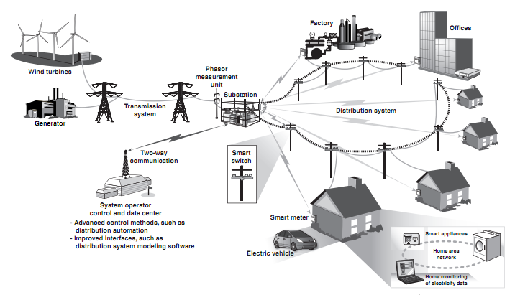

Figure 1.1: Smart Grid

## 1.2 Objectives

The main objectives of our project include designing a range-unbounded home automation system, enabling control and monitoring of appliances over the internet, detecting occupancy of a given area via means of a web camera only, accurately detecting humans and other subjects of interest as per requirement using only the web camera and intelligent algorithms, promoting energy saving by implementing automatic switch off and to comply with smart grid initiatives by enabling smart monitoring of usage of electricity.

## 1.3 Summary

The ability to control events and circumstances at every level is a privilege of the modern world. This privilege is possible through the use of home automation systems, wherein a central control system is installed to facilitate and manipulate the audio-visual communication and environmental resources in one’s home.

# 

# Chapter 2: Literature Survey

This chapter provides an insight into the previous related work which has been carried out, and also the basic details of the hardware and software requirements of the project.

## 2.1 Introduction

There are many definitions of home automation available in the literature. K. Bromley, M. Perry, and G. Webb describe home automation as the introduction of technology within the home to enhance the quality of life of its occupants, through the provision of different services such as telehealth, multimedia entertainment and energy conservation [1]. There has been significant research into the field of home automation. The X10 industry standard, developed in 1975 for communication between electronic devices, is the oldest standard identified from the author’s review, providing limited control over household devices through the home’s power lines. Recently, research into the field of home automation has continued to receive much attention in academia. A. R. Al-Ali and M. Al-Rousan developed a Java based home automation system [2]. An embedded board physically connected all the home automation devices and, through integration with a personal computer (PC) based web server, provided remote access to the system. The use of Java technology, which incorporates built-in network security features, produces a secure solution. However, the system requires an intrusive and expensive wired installation and the use of a high end PC. N. Sriskanthan, F. Tan and A. Karande introduced a Bluetooth based home automation system [3], consisting of a primary controller and a number of Bluetooth sub-controllers. Each home device is physically connected to a local Bluetooth sub-controller. The home devices communicate with their respective sub-controller using wired communications. From the sub-controller all communications are sent to the primary controller using wireless communications. It is desirable for each home device to have a dedicated Bluetooth module. However, due to the fiscal expense of Bluetooth technology, a single module is shared amongst several devices. This architecture reduces the amount of physical wiring required and hence the intrusiveness of the installation, through the use of wireless technology. However, the architecture does not completely alleviate the intrusiveness of the installation due to the incorporation of some wired communications. Moreover the sharing of a single Bluetooth module between numerous devices has the disadvantage of incurring an access delay. H. Ardam and I. Coskun introduced a phone based remote controller for home and office automation [4]. The system differs in that all communications occur over a fixed telephone line and not over the Internet. The system can be accessed using any telephone that supports dual tone multiple frequency (DTMF). The disadvantages of this system are threefold: users are not provided with a graphical user interface, users have to remember an access code, and they have to remember which buttons to press for the control of connected devices. T. Baudel and M. Beaudouin-Lafon proposed a novel control network, using hand gestures [5]. The controller uses a glove to relay hand gestures to the system. The problem with the system lies in the inaccuracy of hand gestures, with the potential for normal arm movements being inaccurately interpreted as commands. Moreover, there is the risk of user fatigue if repetitive hand gestures are required. The introduction provides a short review of the existing academic research into home automation. The publicly available research into home automation lies predominantly in the academic arena, with little industrial research being publically available. The adoption of home automation technologies into commercial systems has been limited, and where available consumer uptake has been slow. Until now, the most common design approximation in home automation has been considering user needs and current technologies to deploy ad hoc solutions. This has led to systems that are too technology dependent, even in the research world. [6]

There have been several commercial and research projects on smart homes and voice recognition systems. Figure 2.1 shows an integrated platform for home security, monitoring and automation (SMA) from uControl [7].  
 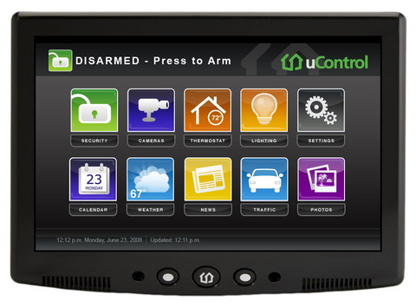

Figure 2.1: uControl Home Security, Monitoring and Automation

The system is a 7-inch touch screen that can wirelessly be connected to security alarms and other home appliances. The home automation through this system requires holding and interacting with a large panel which constraints the physical movements of the user [8]. Another popular commercially available system for home automation is from Home Automated Living (HAL) [9]. HAL software taps the power of an existing PC to control the home. It provides speech command interface. A big advantage of this system is it can send commands all over the house using the existing highway of electrical wires inside the home’s walls. No new wires means HAL is easy and inexpensive to install. However, most of these products sold in the market are heavily priced and often require significant home make over.

A key to the home automation system is the capability for remote operation. Considerable efforts have been put into the development of remote control systems for home automation. Earlier systems are mainly based on the use of telephone line, such as a phone-based system for home automation using a hardware-based remote controller [4][10], and a personal computer [12]. The above systems make use of the telephone as the remote control input device and have no any friendly user interface. With the proliferation of Internet, various Internet-based remote control architectures for home automation have been proposed [2][13-16]. These systems rely on the Internet as the medium for communication and generally feature friendly graphical user interfaces. The Internet-based approach requires a home server running on an Internet-connected personal computer all the time, which would hardly become popular or ordinary homes. Wireless connectivity is another desired feature in home automation systems as it provides mobility, flexibility, and no additional wiring. A Bluetooth-based wireless home network connecting the controller computer and home appliances has been presented in [3][17]. Unfortunately, due to the short coverage-range of the Bluetooth technology, the wireless connectivity provided by the Bluetooth-based systems is limited within the home environment and does not allow a user to control home appliances truly remotely.

## 2.2 Hardware Requirement

This section includes the brief description of the hardware used in this project. Hardware used includes Microcontroller, 7-segment Display and Solid-State Relays which will be discussed in detail.

### 2.2.1 Raspberry Pi Model B

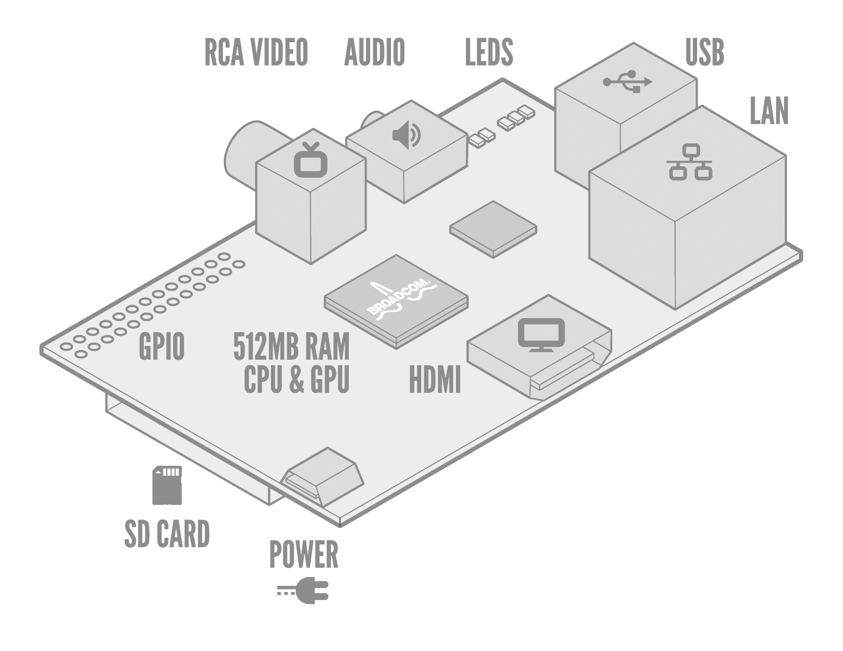

Figure 2.2: Raspberry Pi

The Raspberry Pi (shown in Fig. 2.2) is a credit-card sized computer. It measures 85.60mm x 56mm x 21mm, with a little overlap for the SD card and connectors which project over the edges. It weighs 45g. The full specifications are given below.

Table 2.1: Raspberry Pi Specifications

|  |  |
| --- | --- |
| Price | US$35 |
| SoC | Broadcom BCM2835 (CPU, GPU, DSP, SDRAM, and single USB port) |
| CPU | 700 MHz ARM1176JZF-S core (ARM11 family) |
| GPU | Broadcom VideoCore IV  OpenGL ES 2.0 (24 GFLOPS)  MPEG-2 and VC-1 (with license), 1080p30 h.264/MPEG-4 AVC high-profile decoder and encoder |
| Memory (SDRAM) | 512 MB (shared with GPU) |
| USB 2.0 Ports | 2 (via the built in integrated 3-port USB hub) |
| Video Outputs | Composite RCA (PAL and NTSC), HDMI (rev 1.3 & 1.4), raw LCD Panels via DSI  14 HDMI resolutions from 640×350 to 1920×1200 plus various PAL and NTSC standards |
| Audio Outputs | 3.5 mm jack, HDMI and  I²S audio (also potentially for audio input) |
| Onboard Storage | SD / MMC / SDIO card slot (3.3V card power support only) |
| Onboard Network | 10/100 Ethernet (8P8C) USB adapter on the third port of the USB hub |
| Low-level Peripherals | 8 × GPIO, UART, I²C bus, SPI bus with two chip selects, I²S audio, +3.3 V, +5 V, ground |
| Power Rating | 700 mA (3.5 W) |
| Power Source | 5 volts via MicroUSB or GPIO header |
| Size | 85.60 mm × 53.98 mm (3.370 in × 2.125 in) |
| Weight | 45 g (1.6 oz) |
| Operating Systems | Arch Linux ARM, Debian Linux, Fedora, FreeBSD, Plan 9, Raspbian OS, RISC OS, Slackware Linux |

The Raspberry Pi board has a 26-pin 2.54 mm expansion header, marked as P1, arranged in a 2x13 strip (shown in Fig. 2.3). It provides 8 GPIO pins plus access to I²C, SPI, UART as well as +3.3 V, +5 V and GND supply lines. All the GPIO pins can be reconfigured to provide alternate functions. At reset only pins GPIO 14 & 15 are assigned to the alternate function UART, these two can be switched back to GPIO to provide a total of 17 GPIO pins.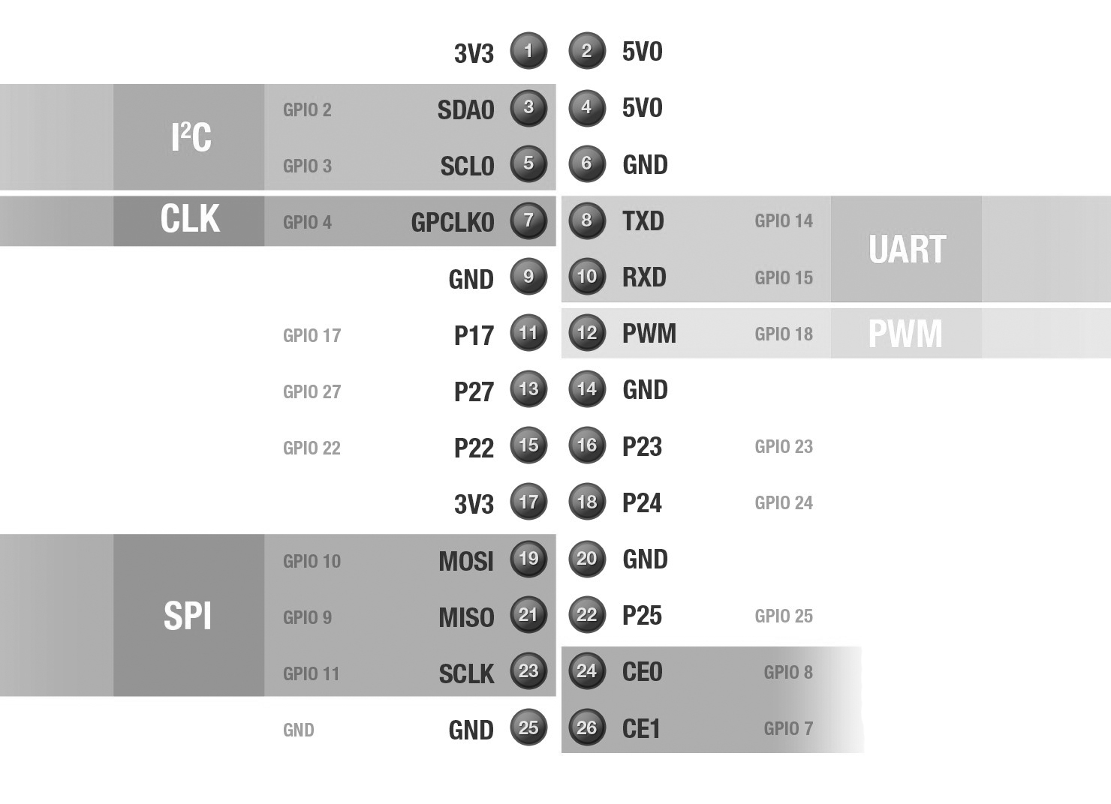

Figure 2.3: Raspberry Pi Pin Diagram

*Pins 1 and 17: 3V3*

Power supply pins, 3.3V

*Pins 2 and 4: 5V0*

Power supply pins, 5.0V

*Pins 3 and 5: I2C*

This is a low-speed interface used to communicate with multiple simple devices and sensors via a two-wire interface. Inter-Integrated Circuit (I2C) is a serial bus interface which supports multiple devices and only requires two wires for communication (no separate clock or device select needed). It is, however, limited to relatively low speeds (usually 10-100kbit/s).

*Pins 6, 9, 14, 20 and 25: GND*

Ground pins. These are used for the purpose of giving common ground to the circuits connected to the Raspberry Pi. If the circuit is not grounded carefully, it will first and foremost fail to work, and on top of that may also lead to damage of components.

*Pin 7: CLK*

Clock (CLK) signals are used to provide a pulse that can synchronise different parts of a system that perform actions which are time sensitive to each other. GPCLK0 is a general purpose clock that generates a square-wave clock signal up to a maximum frequency of around 75MHz.

*Pins 8 and 10: UART*

The UART pins on the Raspberry Pi are primarily provided for access to the serial console which is a relatively advanced feature. Universal Asynchronous Receiver/Transmitter (UART) is a method of transmitting data over a serial connection. Both of the communicating devices contains a shift register that converts the bytes of data being transmitted into a stream of bits.

*Pin 12: PWM*

This pin provides an ‘analogue style’ supply that can be used for controlling motors and LEDs. With pulse-width modulation (PWM) the amount of power delivered to the device is controlled by switching the supply on and off very quickly, typically thousands of times a second.

*Pins 19, 21, 23, 24 and 26: SPI*

This is often used to read more complicated sensors, drive simple displays, or communicate between devices. Serial Peripheral Interface Bus (SPI) is a synchronous full-duplex (two way) serial connection. Communication happens between a master device and slave device with the master device providing synchronisation. The data is transmitted on the MOSI (master-out, slave-in) and MISO (master-in, slave-out) pins. Each transmission is synchronised by a clock pulse on SCLK.

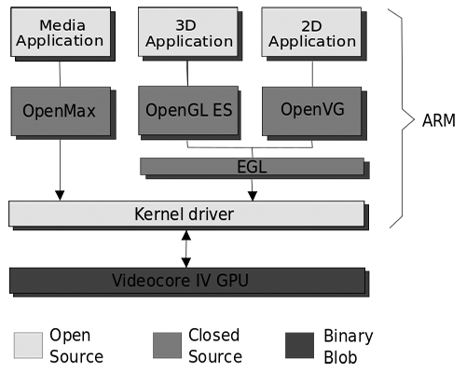

Figure 2.4: Raspberry Pi Architecture Block Diagram

### 2.2.2 Webcam as an Occupancy Sensor

A traditional occupancy sensor is a lighting control device that detects occupancy of a space by people and turns the lights on or off automatically, using infrared or ultrasonic technology. Occupancy sensors are typically used to save energy, provide automatic control, and comply with building codes.

Typical exterior occupancy controls use Passive Infrared (PIR) technology to detect motion and their ability to recognize occupancy can be severely diminished in hot or cold environments. In high temperature environments a human body can blend into the background while in cold temperatures, heavy clothing can provide a type of camouflage, limiting how much infrared is radiated from the body. Coupled with PIR’s common use of Fresnel type lenses that have the potential to create “dead zones” in coverage, the failure of the sensor to effectively recognize occupancy can create a potentially unsafe environment for occupants.

Hence, the use of image-based occupancy sensors is increasing, due to the decreasing cost of such devices and various advantages. Unlike PIR technology, image-based occupancy sensors are not affected by ambient conditions and are able detect movement of any object within the field of view.

The field of view of the sensor must be carefully selected/adjusted so that it responds only to motion in the space served by the controlled lighting. For example, an occupancy sensor controlling lights in an office should not detect motion in the corridor outside the office. Sensors and their placement are never perfect, therefore most systems incorporate a delay time before switching. This delay time is often user-selectable, but a typical default value is 15 minutes. This means that the sensor must detect no motion for the entire delay time before the lights are switched. Most systems switch lights off at the end of the delay time, but more sophisticated systems with dimming technology reduce lighting slowly to a minimum level over several minutes. If lights are off and an occupant re-enters a space, most current systems switch lights back on when motion is detected.

### 2.2.3 Solid State Relay

A solid-state relay (SSR) is an electronic switching device in which a small control signal controls a larger load current or voltage. It consists of a sensor which responds to an appropriate input (control signal), a solid-state electronic switching device which switches power to the load circuitry, and some coupling mechanism to enable the control signal to activate this switch without mechanical parts (shown in Fig. 2.5). The relay may be designed to switch either AC or DC to the load. It serves the same function as an electromechanical relay, but has no moving parts.

### 2.2.4 Seven-segment Display

The seven segments are arranged as a rectangle of two vertical segments on each side with one horizontal segment on the top, middle, and bottom (as shown in Fig. 2.6). Additionally, the seventh segment bisects the rectangle horizontally. The segments of a 7-segment display are referred to by the letters A to G, where the optional DP decimal point (an "eighth segment") is used for the display of non-integer numbers.

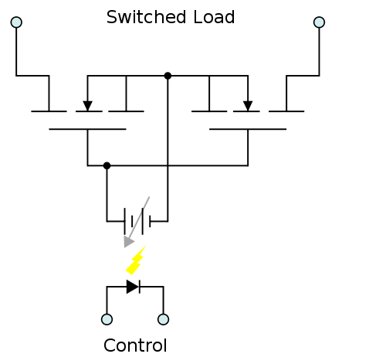

Figure 2.5: Solid State Relay

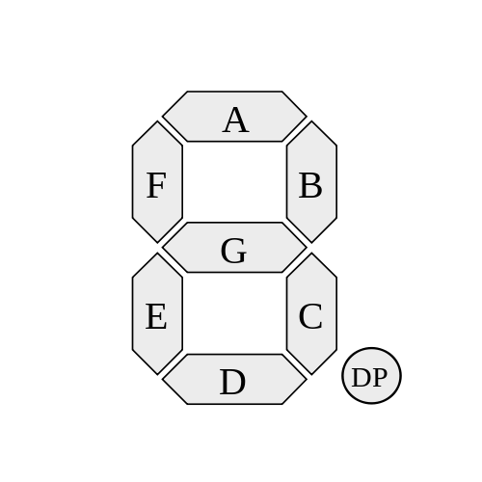

Figure 2.6: Seven-segment Display

### 2.2.5 BCD to 7-segment Decoder/Driver (74LS47)

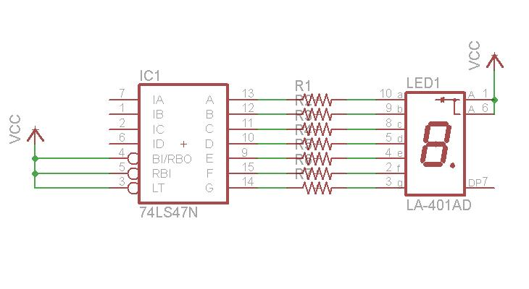

Figure 2.7: Circuit for BCD to 7-segment display using 74LS47

The circuit diagram of the connection of 74LS47 with a 7-segment display is shown in Fig. 2.7. The 74LS47 IC accepts 4-bit binary-coded-decimal (BCD) and, depending on the state of the auxiliary inputs, decodes this data to drive a 7-segment display indicator. The truth table is shown below.

Table 2.2: Truth table for BCD to 7-segment display using 74LS47

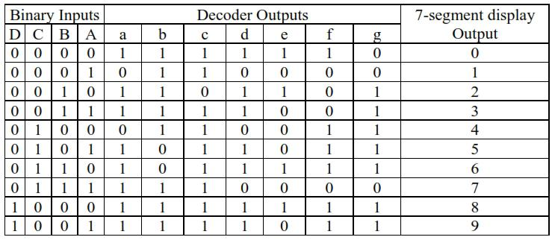

## 2.3 Software Requirements

This section includes the brief description of the software concepts used in this project. This includes Android, Server-Client Modules, etc. which will be discussed in detail.

### 2.3.1 Android

Android is a Linux-based operating system designed primarily for touchscreen mobile devices such as smartphones and tablet computers. Initially developed by Android, Inc., which Google backed financially and later bought in 2005, Android was unveiled in 2007 along with the founding of the Open Handset Alliance: a consortium of hardware, software, and telecommunication companies devoted to advancing open standards for mobile devices.

### 2.3.2 Client-Server Model

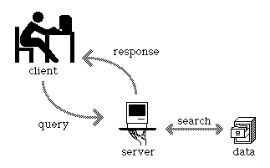

Figure 2.8: Client-Server Model

The client–server model (Fig. 2.8) is a distributed application structure in computing that partitions tasks or workloads between the providers of a resource or service, called servers, and service requesters, called clients. Often clients and servers communicate over a computer network on separate hardware, but both client and server may reside in the same system. A server is a host that is running one or more server programs which share their resources with clients. A client does not share any of its resources, but requests a server's content or service function. Clients therefore initiate communication sessions with servers which await incoming requests.

### 2.3.3 Internet Protocols

The Transmission Control Protocol (TCP) is one of the two original core protocols of the Internet protocol suite (IP), and is so common that the entire suite is often called TCP/IP. TCP provides reliable, ordered, error-checked delivery of a stream of octets between programs running on computers connected to an intranet or the public Internet.

The User Datagram Protocol (UDP) is the other core member of the Internet protocol suite. With UDP, computer applications can send messages, in this case referred to as datagrams, to other hosts on an Internet Protocol (IP) network without prior communications to set up special transmission channels or data paths.

The next chapter deals with the exact scope of the project.

# Chapter 3: Scope of Present Work

This chapter deals with the scope of the project, including the statement of the project and the objectives which are to be achieved.

## 3.1 Statement of the Project

Enabling control and monitoring of appliances over internet protocol using Android application with webcam-based occupancy sensing and integration with smart grid is deemed to be a cost-effective way of bringing luxury along with energy saving to users since the components used are simple and inexpensive. The use of the Raspberry Pi as a processor for this purpose greatly enhances the abilities of the system at an affordable cost. Since web cameras are decreasing in cost rapidly, it is an ideal solution for occupancy sensing. The Android application is designed with simplicity and beauty in mind, and offers a user-friendly, simple and intuitive interface to access the various appliances for both monitoring and control, and it is deemed to be the best platform on which to base the remote control due to the ubiquitousness of smartphones all across the world today.

## 3.2 Objectives

* To design a range-unbounded home automation system.
* To enable control and monitoring of appliances over the internet instead of only locally.
* To detect occupancy of a given area via means of a web camera only.
* To accurately detect humans and other subjects of interest as per requirement using only the web camera and intelligent algorithms.
* To promote energy saving by implementing automatic switch off based on detected occupancy.
* To comply with smart grid initiatives by enabling smart monitoring of usage of electricity.
* To integrate luxury with necessity.
* To make it available to the general public through intelligent design.

The next chapter deals with the actual work carried out in the project.

# Chapter 4: Present Work

In this chapter, the present work carried out on both the software and hardware aspects is elaborated.

## 4.1 Software

### 4.1.1 Introduction

Figure 4.1: Overview Block Diagram

The main components of the software part of the project include

* Web Camera Program
* Raspberry Pi Programs
* Android App

The programming languages used to code the various software components of the project include

* OpenCV for the Web Camera Program
* C++ for the Web Camera Program
* Python for the Raspberry Pi Programs
* Android API for the Android App

### 4.1.2 Web Camera program

The web camera program is designed to detect a given predefined subject of interest in the frame of view of the web camera. The subject of interest can be any shape, figure or object. Since the requirement of the project is human occupancy detection, the program is designed to detect humans as the subject of interest.

There are various advantages of using the webcam for detection of humans, including

* it works well in optimal conditions
* the hardware costs are rapidly declining
* the program only detects the predefined subject of interest and not other objects

However, there are also certain disadvantages which occur while using this method of detection of occupancy, such as

* detection varies among human structure and size
* dependent on time of day

The difficulties faced in this method of occupancy detection may be easily overcome by better training of the detection algorithm using a vast database, to recognize humans of all shapes and sizes. Additionally, the webcam can be enabled to work at night by adding night vision equipment to it.

*Algorithm:*

1. Take video input and keep looking for human-like shapes

2. Detect human-like shape

Visual feedback - Draw rectangle

Send control signal

1 for NOT DETECTED

2 for DETECTED

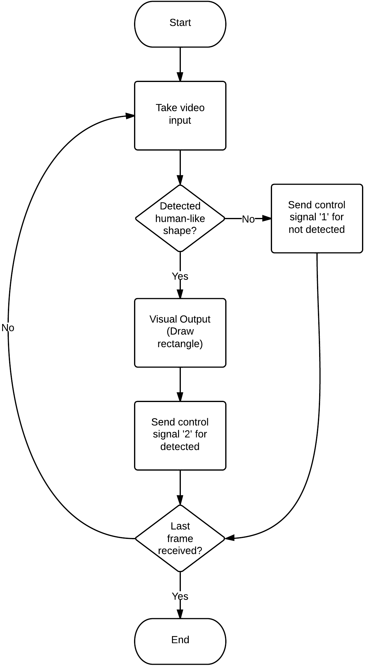

Figure 4.2: Web Cam Program Flowchart

The webcam program was done using the software languages OpenCV and C++, coupled with the concept of HOG (Histogram of Oriented Gradients).

The future developments for the webcam program include

* highly refined human detection which is much more efficient and works flawlessly for most, if not all, shapes, sizes and colours of humans
* the addition of capability to detect any other subjects of interest apart from humans (for example, pets) in order to enable fine tuning to the requirements of the user

### 4.1.3 Raspberry Pi programs

There are basically 2 Python codes running on the Raspberry Pi processor, namely

* Web (web_rpi.py), and
* Server (server_rpi.py)

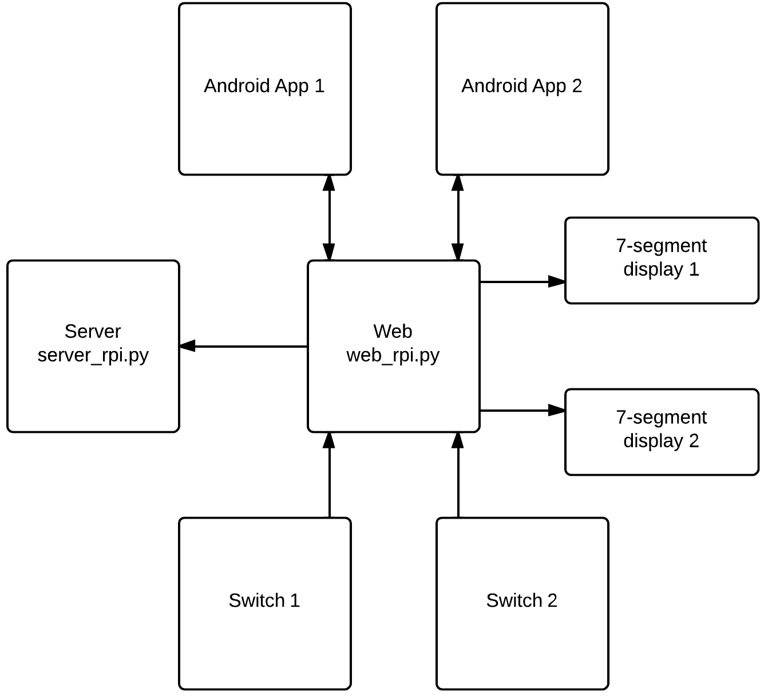

Figure 4.3: Raspberry Pi programs Block Diagram

The Web code is an intermediate program to handle all connections and requests from the various other components of the system, such as Android app. It performs the following major operations.

* Filtering of data
* Restricting direct control from user applications to the control pins of the Raspberry Pi
* Enabling security, since no other program or user applications are allowed access to the Raspberry Pi control pins directly.

It has two roles, namely it acts as a client to the Server code, and also acts as a server to the user end applications.

The Server code is used to connect via a single serial connection to the Web code. Data is sent serially because there is only one connection between the Server and Web codes. The Server code activates the appropriate pins on the Raspberry Pi control pins upon receipt of serial data instruction from the Web code. The Server code acts as the only direct control of the control pins of the Raspberry Pi. No other program or code is allowed to access the pins directly, and all access is only through the Server code.

*Algorithm:*

1. Wait on TCP server socket (listen on port) continuously

2. Takes data from Web serially

3. When any data is received, i. relays backward (broadcast) that data, ii. creates child program on a different thread

=> Child program activates the appropriate pins for output

4. Loop back to listening mode.

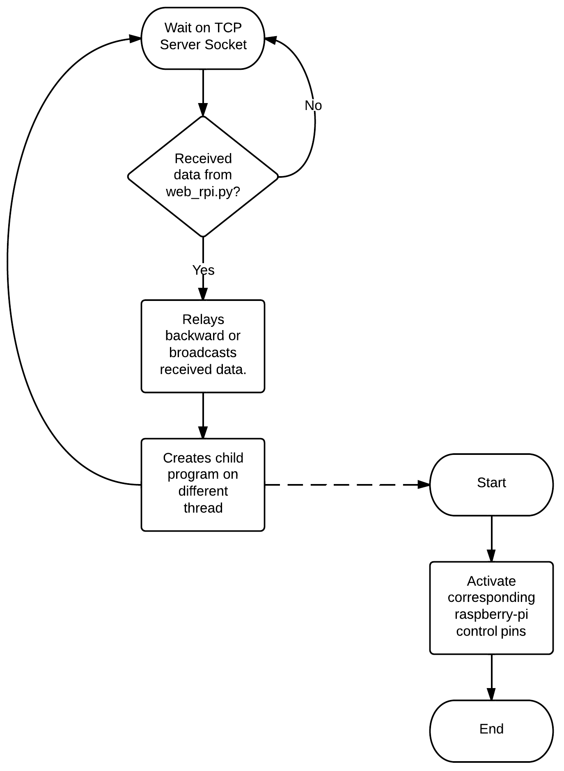

Figure 4.4: Server Program flowchart

### 4.1.4 Switch Program

The switch program is used to interface the physical push-button switches with the rest of the software. The push-button switch inputs are given to the control pins of the Raspberry Pi and the switch program constantly monitors or checks the pins for high (+5V level) input from the switches. Once the high input is detected, it sets a flag for debouncing operation. Bouncing is the tendency of any two metal contacts in an electronic device to generate multiple signals as the contacts close or open; debouncing is any kind of hardware device or software that ensures that only a single signal will be acted upon for a single opening or closing of a contact. Hence, when the flag is set, a single press of the push-button will not be read as multiple presses. The program then sends data to the Web (web_rpi.py) program, which in turn sends data serially to the Server (server_rpi.py) program and enables or disables the respective control pins on the Raspberry Pi.

Algorithm: (while loop)

1. Wait for high input from switch

2. Upon receiving a high, sets the flag (debouncing purpose)

3. Send respective signal data to Web (depending on which switch pressed)

### 4.1.5 Driver Program for 7-segment Display

The 7-segment display driver program is used to drive the 7-segment display outputs through the 74LS47 BCD to 7-segment decoder IC. The required digits to be displayed for this application are only numerals 0, 1, 2 and 3 hence only 2 inputs to the respective 74LS47 IC are required, for each 7-segment display. The program sends the appropriate BCD digit, i.e. 00, 01, 10 or 11 depending on the current state of the appliance.

* For appliances without intensity/speed control
  + 0 for off state
  + 1 for on state

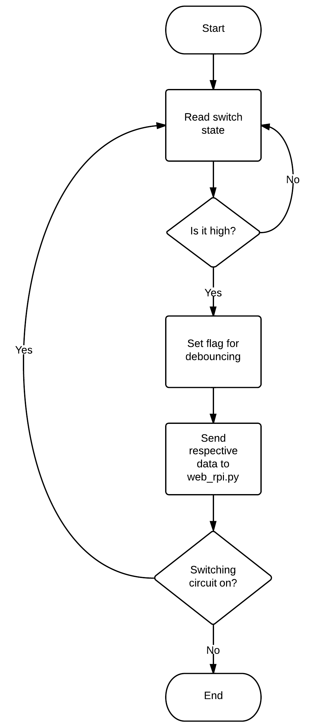

Figure 4.5: Switch Program flowchart

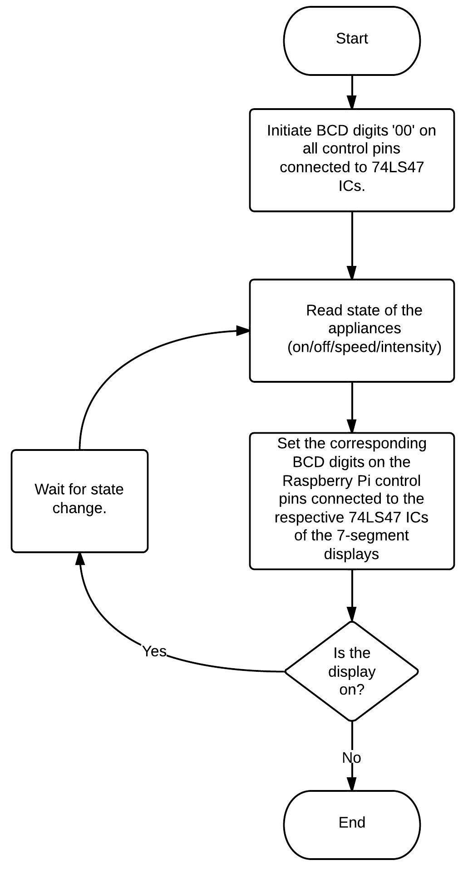

Figure 4.6: Flowchart for 7-segment display driver

* For appliances with intensity/speed control
  + 0 for off state
  + 1 for 1%-50% intensity/speed
  + 2 for 50%-99% intensity/speed
  + 3 for full (100%) intensity/speed

*Algorithm:*

1. Initiate BCD digits (00) on all the Raspberry Pi control pins connected to the respective 74LS47 ICs of the 7-segment displays.
2. Read state of the appliances (on/off/speed/intensity).
3. Set the corresponding BCD digits on the Raspberry Pi control pins connected to the respective 74LS47 ICs of the 7-segment displays.
4. Wait for state change.

## 4.2 Hardware

### 4.2.1 Transformer

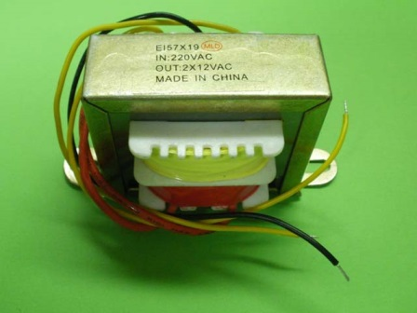

Figure 4.7: Transformer

The transformer used is rated 1000mA and it is a step-down transformer which converts 220V AC to 12-0-12V AC. It provides a 3-wire output with centre tap, It measures 2.5" from mounts end to end and it is conveniently provided with screw holes on the mounts. The transformer is basically used to supply the Power Supply Unit, which in turn supplies the remaining components. The power rating is suitable for the purpose of this project since the Power Supply Unit is rated for 1A and hence there is no problem of overloading of transformer. 12-0-12V AC output is ideal since the Power Supply Unit being used takes inputs of a similar fashion.

### 4.2.2 Power Supply Unit

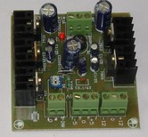

Figure 4.8: Power Supply Unit

The Power Supply Unit is used as the main supply to all other components including Vccs and ground pins of all ICs. It takes an input voltage of 12-0-12V AC and provides output voltages of +5, +12, -5 and -12 V DC. The output voltage is adjustable between 1.4V and 30 V. All the inputs and outputs are connected to terminal blocks as shown, for easy wiring to the rest of the circuitry. The voltage regulators used in this Power Supply Unit are from the µA7800 series which are basically 3-terminal regulators with output current up to 1.5A, internal thermal-overload protection, high power-dissipation capability, internal short-circuit current limiting and output transistor safe-area compensation. The specific voltage regulator used for the purpose of project is the µA7805 IC.

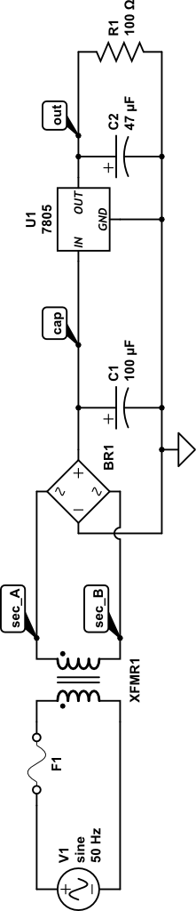

Figure 4.9: Power Supply Circuit Diagram

### 4.2.3 Solid State Relay

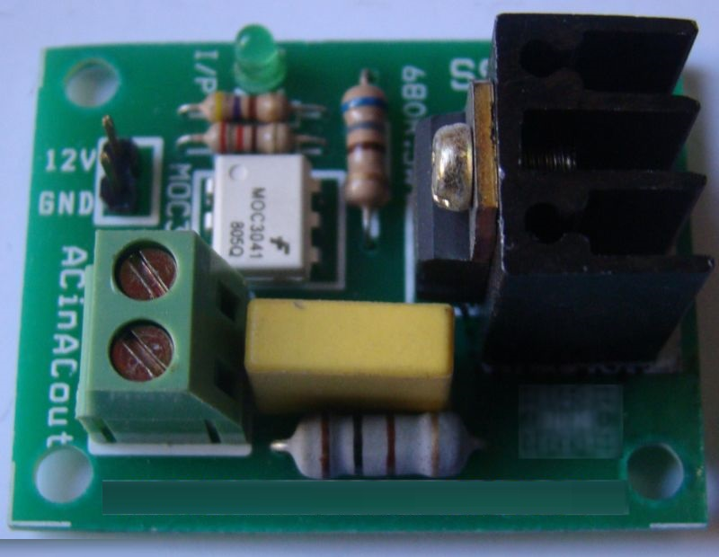

Figure 4.10: Solid State Relay

The Solid State Relay used is a 12V triac-based relay with BTB04-600SL IC. It is rated for 4A/250V AC input. The input logic is 12V level and it is interfaced with MOC3041 for opto-isolation. The input pin is provided with burg stick type connectors for ease of use and output is provided with 6A terminal block. The BTB04-600SL 4-quadrants triac is intended for general purpose applications where high surge current capability is required, such as lighting, corded power tools, industrial purposes and hence it is ideal for use in this case. The MOC3041 device consists of gallium arsenide infrared emitting diodes optically coupled to a monolithic silicon detector performing the function of a Zero Voltage Crossing bilateral triac driver. It is designed for use with a triac in the interface of logic systems to equipment powered from 230V AC lines.

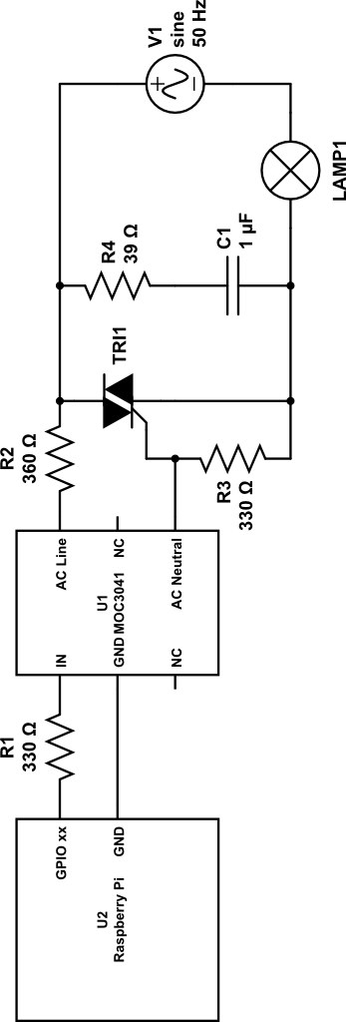

Figure 4.11: SSR Circuit using MOC 3041

### 4.2.4 Push-button Switches

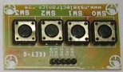

Figure 4.12: Push Button Switches

The switches used are simple tact switches with input pins connected to burg sticks for easy interface with the wiring. A tact switch is type of switch that is only on when the button is pressed. As soon as the button is released, the circuit is broken. The problem with this type of switch is that the output is high when the switch is in on state, however it is floating when the switch is in off state (i.e. when the connection is broken). Hence a transistor-based circuit was designed for the following purposes.

* To pull the output of switch to ground when the switch is in off state.
* To limit the input current to the Raspberry Pi to below 5 mA.

The transistor circuit is a simple design circuit using the transistors in cut-off and saturation regions for off and on state respectively. The transistor operates in cut-off region when the physical switch is in open position and hence it provides output of high to the respective pin of the Raspberry Pi. Similarly, when the physical switch is closed, the transistor operates in saturation region and hence it provides output of low to the respective pin of the Raspberry Pi (see Figure 4.13).

### 4.2.5 Raspberry Pi Extension Board

The Raspberry Pi Extension Board is a custom designed board to duplicate the pins of the Raspberry Pi in order to provide accessibility and customisability to the project. A SCSI (Small Computer System Interface) cable is used to firstly replicate all the Raspberry Pi pins on to the extension board. These pins are now connected via custom solder via current limiting resistors to various parts of the circuitry (See figure 21) as follows:

* Input from switches: 4 pins
* Output to display unit: 4 pins
* Control pins to SSRs for on-off control of devices: 2 pins
* Control pin to SSR for speed control of device: 1 pin

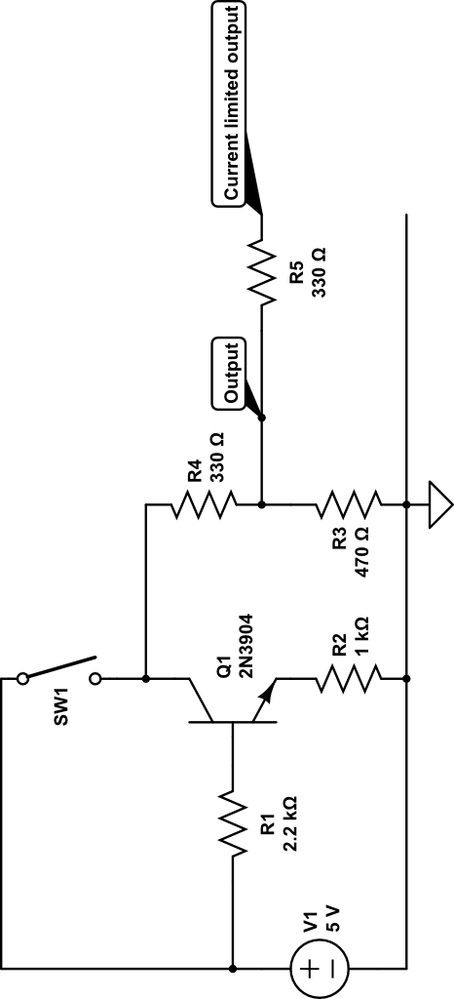

Figure 4.13: Switch circuit using transistor in cut-off and saturation regions

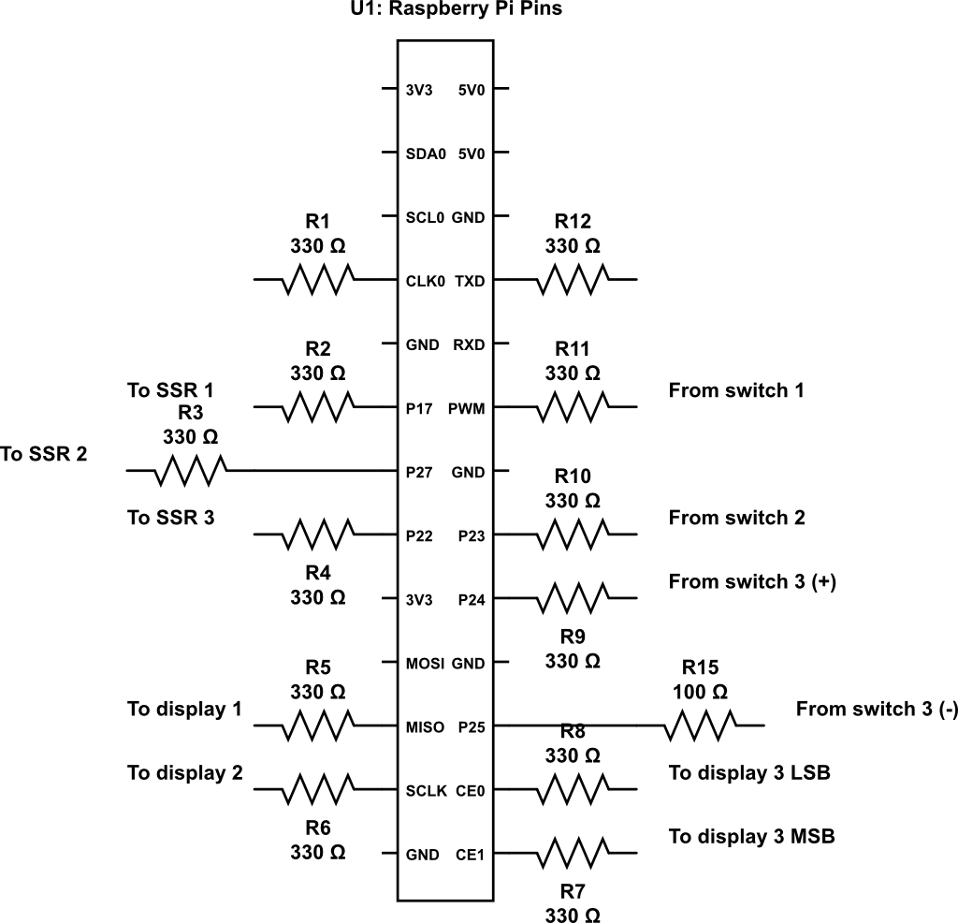

Figure 4.14: Raspberry Pi Extension Board Circuit Diagram

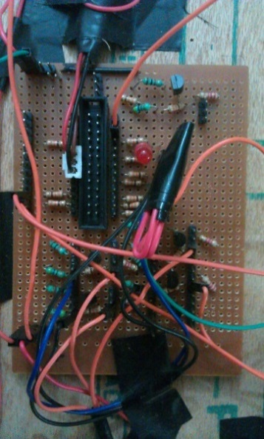

Figure 4.15: Raspberry Pi Extension Board Photograph

# Chapter 5: Results

## 5.1 Result

Smart Grid Compatible Control of Appliances using Internet Protocol is successfully implemented. A large number of applications and advantages thus emerge from this implementation.

## 5.2 Applications

1. Eliminate the need to walk around the house turning off appliances before exiting the home or going to sleep.
2. Turn off all house lights with the touch of a single button.
3. Set a series of events as a routine, for example in the morning, user could designate the thermostat to warm the room, have lights gradually increase intensity, ensure the coffee begins brewing and the television turns on.
4. Program security system to send alert through e-mail or phone when the system detects activity in the home while you are away.
5. Save electrical energy by smart occupancy detection.

## 5.3 Advantages

There are a significant number of advantages, as enumerated below.

1. Adds safety through appliance and lighting control.
2. Increases awareness through security cameras.
3. Increases convenience by enabling speed/intensity control.
4. Saves energy and in turn reduces the electricity bill.
5. Allows control from anywhere in the world.

## 5.4 Disadvantages

With advantages come disadvantages. Some of the disadvantages are as follows.

1. Automation of the home is widely related to the financial costs. The total cost depends on the equipment installed. The more advanced the system; the higher the cost.
2. If there is any damage due to rupturing of cables or the fibers the entire system crashes due to loss of signals. This will not be the case with radio signals or other signals.
3. If the user does not handle the kit safely or if he/she does not use the correct keys to perform the operations, human errors may occur.
4. In very rare cases, the reliability of the home-automated devices varies (decreases).

## 5.5 Screenshots of Android App

|  |  |
| --- | --- |
|  | Figure 5.1: Login Screen |
|  | Figure 5.2: Login Successful |
|  | Figure 5.3: Panel Booting |
|  | Figure 5.4: Panel Booted and Healthy |
|  | Figure 5.5: Navigate Home screen  This screen is used to navigate the various rooms in the house. An example 2-bedroom house is shown here. |
|  | Figure 5.6: Configure IP  The server and port depend upon the IP address as viewed by the Android app. It may be a public or local IP address. |
|  | Figure 5.7: Bedroom Controls  An example bedroom with a light, a fan and an air conditioning unit is shown. |
|  | Figure 5.8: Speed Control  The speed of fan can be controlled using the slide bar provided at the bottom of the Action pane. |
|  | Figure 5.9: Device Usage details  This is a prototype model for demo purposes. The data and details are arbitrary values shown for demonstration purpose, and may vary upon actual implementation. |
|  | Figure 5.10: kWh Manager  This screen displays the relative usage of electricity between the various rooms in the house. For demonstration purposes, the Units are taken to be the time for which any appliances in the room were switched on. |
|  | Figure 5.11: Monthly Bill Details  This is a model template for future implementation and integration with smart grid. Values are for display purposes only. |
|  | Figure 5.12: Rate Slabs |
|  | Figure 5.13: Device-wise Unit Consumption  This screen displays the relative usage of electricity between the various appliances in the room. For demonstration purposes, the Units are taken to be the time for which appliances were switched on. |
|  | Figure 5.14: Room-wise Unit Consumption  This is a model template for future implementation. Values are for display purposes only. |
|  | Figure 5.15: Start and Stop Timer  This feature allows the user to set timers on appliances to enable delayed switch-on or switch-off of devices. In future expansions, it can also be programmed for repetitive daily, weekly and monthly processes. |

# Chapter 6: Conclusion

## 6.1 Scope for future work

This work reports the development of Smart Grid Compatible Control of Appliances using Internet Protocol. The main features include low cost and small size. The low cost design could enable home automation to be brought to the masses, rather than remaining a toy of the affluent.

The design includes webcam-based smart occupancy sensing to allow for energy saving and reduction of electricity bill of the user, hence making it even more appealing for the masses.

In order to further improve the design, some further features could be implemented, including

* highly refined human detection which is much more efficient and works flawlessly for most, if not all, shapes, sizes and colours of humans
* the addition of capability to detect any other subjects of interest apart from humans (for example, pets) in order to enable fine tuning to the requirements of the user
* kWh manager of the Android app completely compatible with the smart grid and displays real-time data from the electricity supplier
* ability to monitor and pay electricity bills through the application
* futuristic buttons or touchscreens to replace switch boards
* seamless integration with smart grid.

## 6.2 Task

The primary objective of this project is to implement a prototype model of Smart Grid Compatible Control of Appliances using Internet Protocol within the limited available resources and economy. The system can also be subjected to further development using advanced techniques.

## 6.3 Achievement

A complete system that can be controlled remotely by the user via internet protocol including occupancy sensing by the use of webcam is successfully implemented.

## 6.4 Final Opinion

This project is a prototype model, hence gives a concept of real implementation and can be installed successfully for more practical applications.

# Bibliography

1. K. Bromley, M. Perry, and G. Webb. "Trends in Smart Home Systems,Connectivity and Services", www.nextwave.org.uk, 2003.
2. A. R. Al-Ali and M. Al-Rousan, "Java-based home automation system", IEEE Transactions on Consumer Electronics, vol. 50, no. 2, pp. 498-504, 2004.
3. N. Sriskanthan, F. Tan and A. Karande, "Bluetooth based home automation system", Microprocessors and Microsystems, Vol. 26, no. 6, pp. 281-289, 2002.
4. H. Ardam and I. Coskun, "A remote controller for home and office appliances by telephone", IEEE Transactions on Consumer Electronics, vol. 44, no. 4, pp. 1291-1297, 1998.
5. T. Baudel and M. Beaudouin-Lafon, "Charade: remote control of objects using free-hand gestures", Communications of the ACM, vol. 36, no. 7, pp. 28-35, 1993.
6. I. T. Han, H. S. Park, Y. K. Jeong, K. R. Park, “An integrated homeserver for communication, broadcast reception, and home automation,”  IEEE Transactions on Consumer Electronics, vol. 52, no. 1, pp. 104-109, Feb. 2006.
7. "UControl Launches OpenSMA (Security, Monitoring and Automation)." Connected Home World Magazine. N.p., 24 Oct. 2010. Web. 22 May 2013.
8. R. Gadalla, “Voice Recognition System for Massey University Smarthouse,” M. Eng thesis, Massey University, Auckland, New Zealand, 2006.
9. "HAL." *HAL*. Home Automated Living, Inc., n.d. Web. 22 May 2013. Available: <http://www.homeautomatedliving.com/default.htm>
10. E. M. C. Wong, “A phone-based remote controller for home and office automation,” IEEE Trans. Consumer Electron., vol. 40, no. 1, pp. 28-34, Feb. 1994.
11. B. Koyuncu, “PC remote control of appliances by using telephone lines,” IEEE Trans. Consumer Electron., vol. 41, no. 1, pp. 201-209, Feb. 1995.
12. N. S. Liang, L. C. Fu, and C. L. Wu, “An integrated, flexible, and Internet-based control architecture for home automation system in the Internet era,” Proceedings of ICRA’02, IEEE International Conference on Robotics and Automation, vol. 2, pp. 1101-1106, 2002.
13. R. J. C. Nunes and J. C. M. Delgado, “An Internet application for home automation,” MELECON 2000, 10th Mediterranean Electrotechnical Conference, vol. 1, pp. 298-301, 2000.
14. P. M. Corcoran, F. Papai and A. Zoldi, “User interface technologies for home appliances and networks,” IEEE Trans. Consumer Electron., vol. 44, No. 3, pp. 679-685, Aug. 1998.
15. P. M. Corcoran and J. Desbonnet, “Browser-style interfaces to a home automation network,” IEEE Trans. Consumer Electron., vol. 43, no. 4, pp. 1063-1069, Nov. 1997.
16. H. Kanma, N. Wakabayashi, R. Kanazawa, and H. Ito, “Home appliance control system over Bluetooth with a cellular phone,” ICCE 2003, IEEE International Conference on Consumer Electron., pp. 380-381, 2003.

.

# Appendix: Datasheets

A.1 Raspberry Pi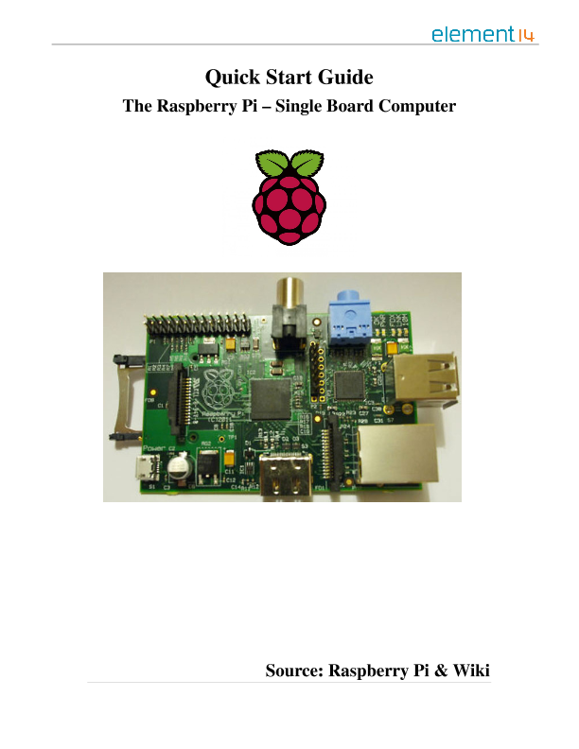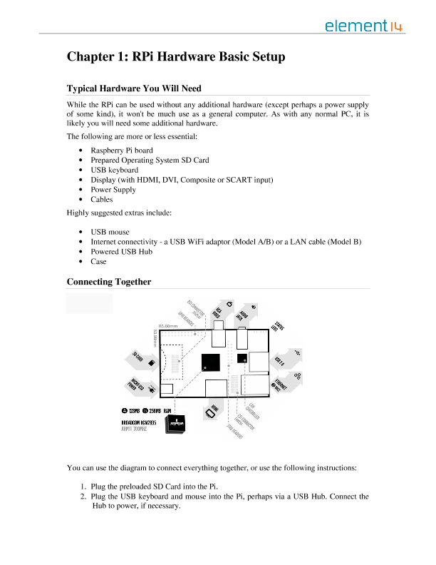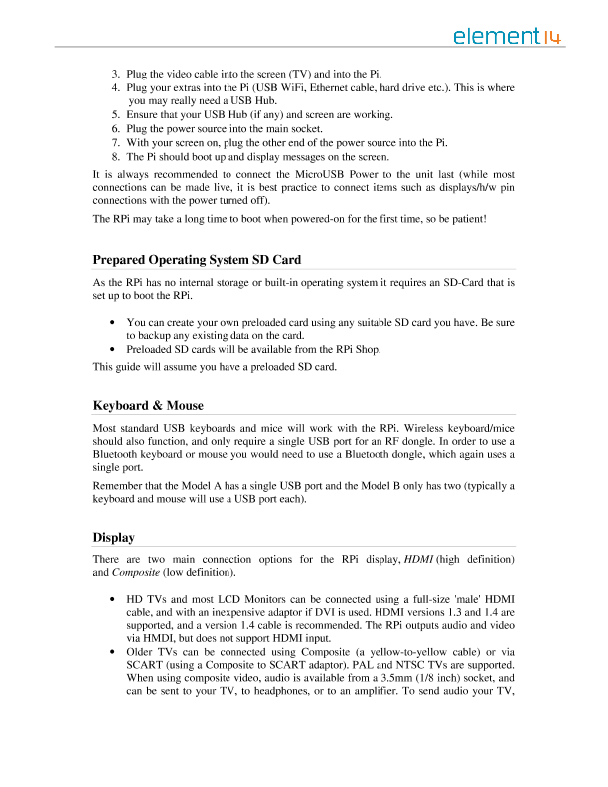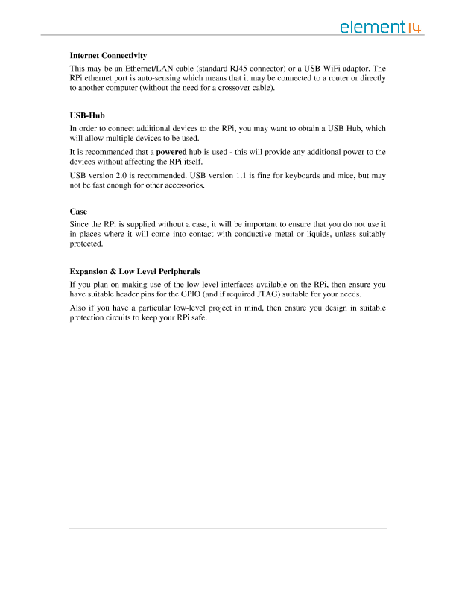

A.2 MOC 3041 Zero-Cross Optoisolator Triac Driver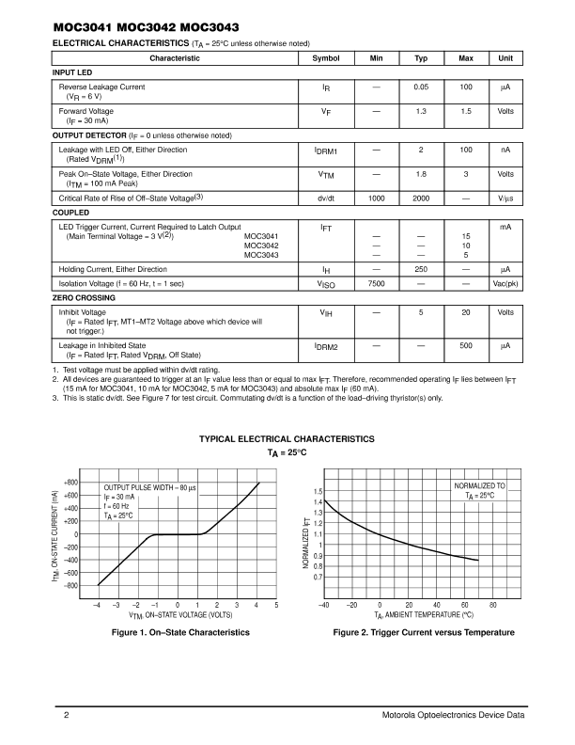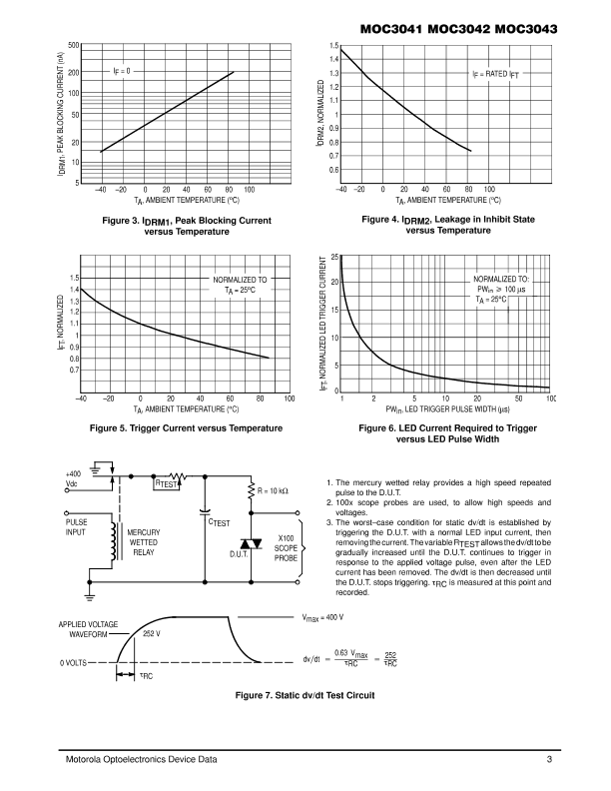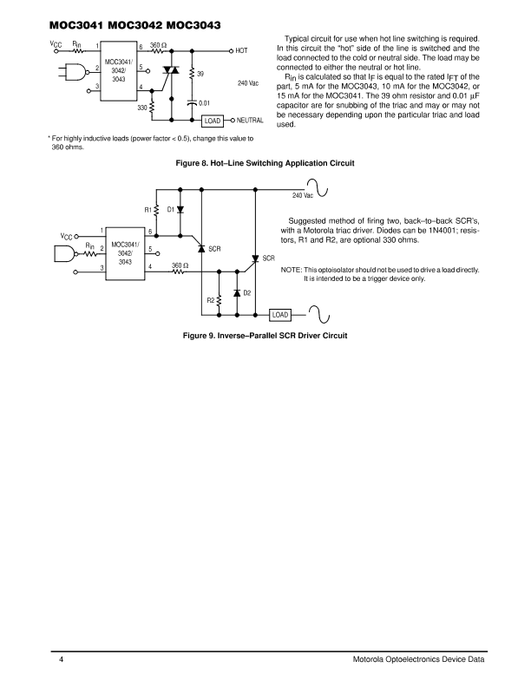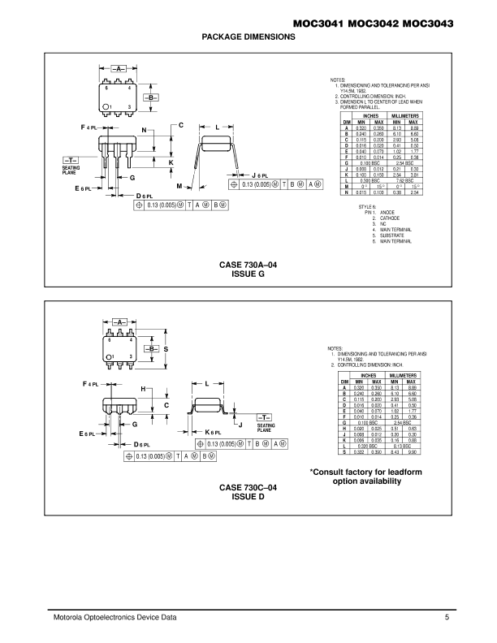

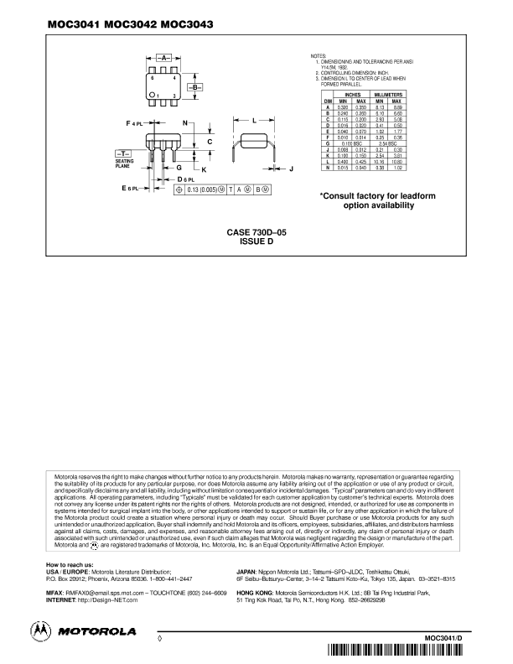

A.3 BTB04-600SL Standard 4A Triac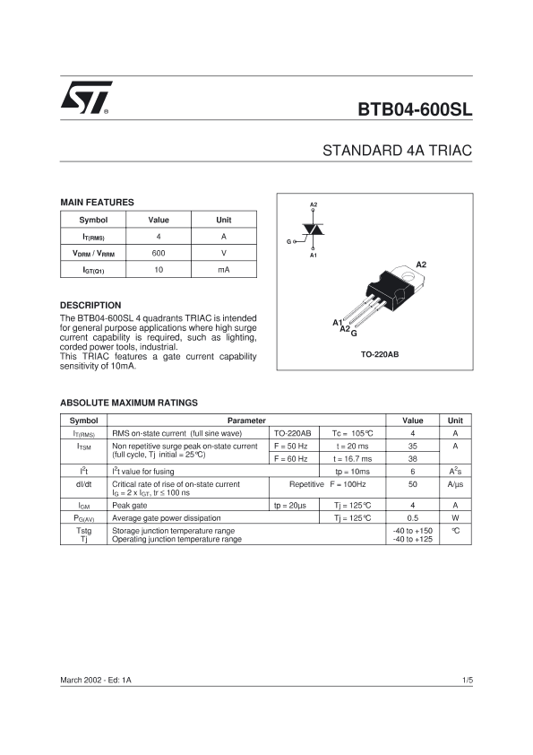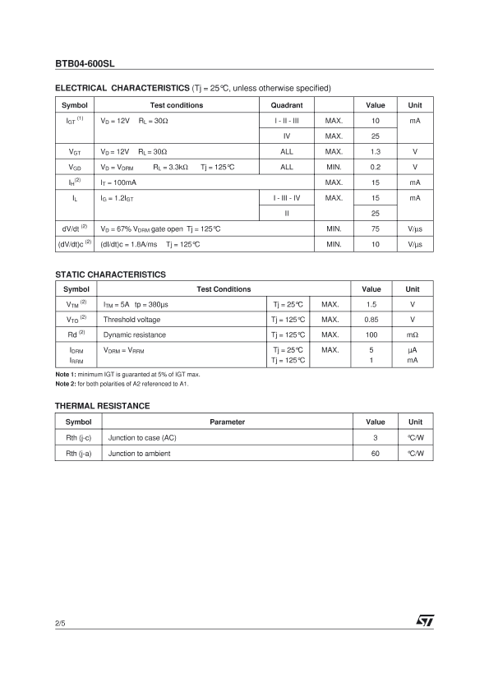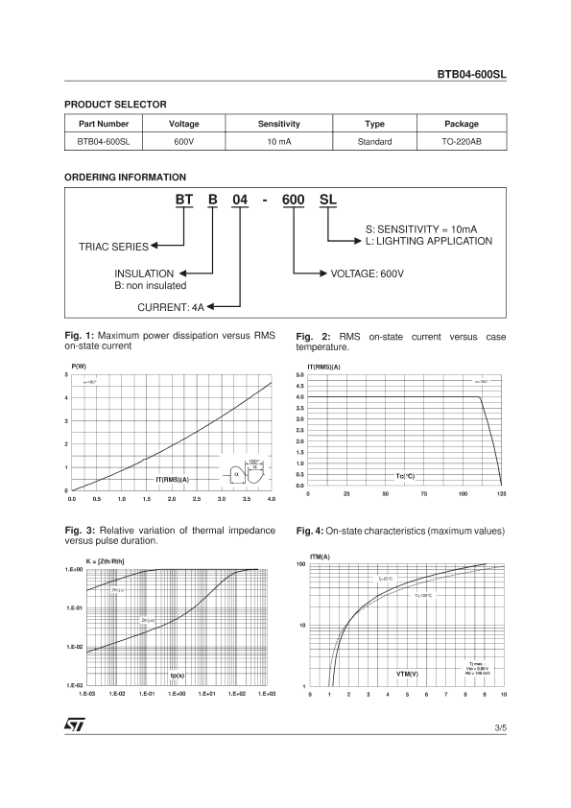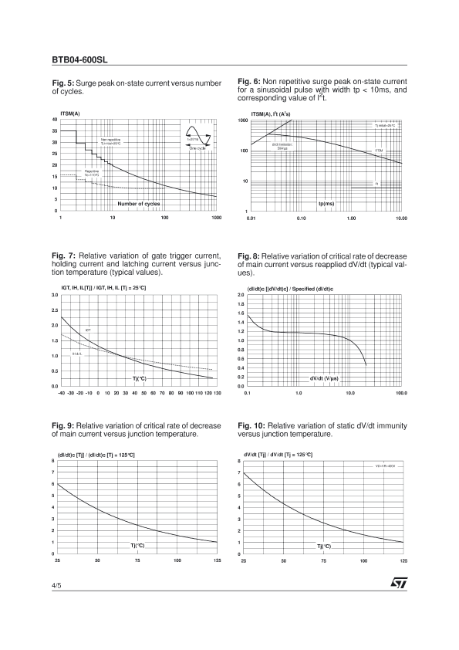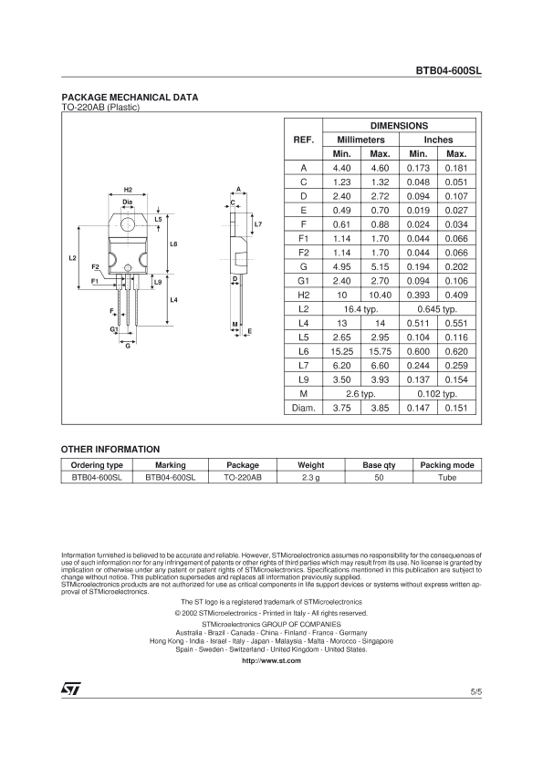

A.4 7447 BCD to 7-segment Decoder/Driver